Section 1(Three ways of styling):

Style the text inside a <div> element using three different methods.

1.1 Inline Styles: Apply a font to color(#800000) and size to 18 directly within the <div> tag.

1.2 Internal Styles: Link an internal stylesheet in the HTML document head and style the text with a different background color(cornflowerblue).

1.3 External Styles: Create an external stylesheet (styles.css) and link it to the HTML document and do the following tasks:

1.3.1 Align the text within the <div>(Hint: text-align center)

1.3.2 Specify the custom font family(arial,sans serif)

1.3.3 Set the font-weight as bold

1.3.4 Adjust the letter spacing between letters.

The output will look like this:
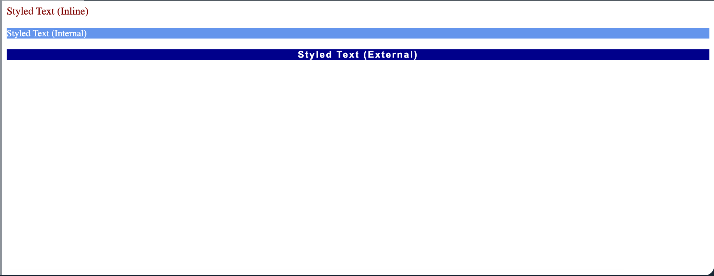

Question 2:

Create a Styled Contact Form. We have already discussed contact form html in week 1. Here is the sample html code for the contact form.

<!DOCTYPE html>
<html lang="en">
<head>
<link rel="stylesheet" href="styles.css">
<title>Contact Us</title>
</head>
<body>
<form id="contactForm">
<label for="name">Name:</label>
<input type="text" class="form-field" id="name" name="name" placeholder="Name">

<label for="email">Email:</label>
<input type="email" id="email" class="form-field" name="email" placeholder="Email">

<label for="message">Message:</label>
<textarea class="form-field" class="form-field" name="message" placeholder="Your message here"></textarea>

<input type="submit" value="Submit">
</form>
</body>
</html>

Contact us form must look like this:
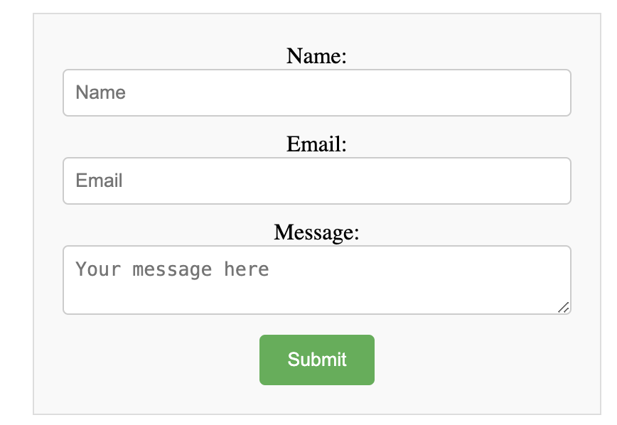

Requirements:
- Universal Selector:
1.1. Reset default margin, padding using universal selector.
1.2. Add border-box as box sizing

- Element Selector:

Style the overall form using an element selector, setting maximum width, margin, padding, border, and background color

- ID Selector:

Center-align the form text using an ID selector (#contactForm).

- Class Selector:

Style text input fields and textareas using a class selector (.form-field), setting width, padding, margin, border, and border-radius.

- Attribute Selector:

Style submit button using an attribute selector input[type="submit"], setting background color, text color, padding, border, border-radius, and cursor pointer.

- Use Pseudo Class:

Add a hover effect to the submit button.

3. Portfolio Site:

Continue styling your portfolio site which was created in workshop 1.

Figma file: https://www.figma.com/design/XcdU9EwRI9ArIXUs4sETVk/Portfolio-Site?node-id=0-1&t=f3ssDEXKQZbz5gu9-1

